26.42: a)
b) 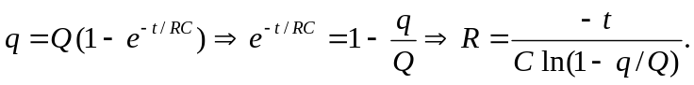
After 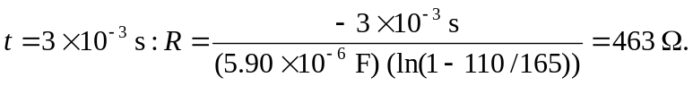
c) If the charge is to be 99% of final value:
